**HUMAN ACTIVITY RECONIGATION FROM SMARTPHONE SENSOR DATA**

Namburi SaiKrishna  
*Computer science and engineering   
Bennett University*Greater Noida ,India  
nk6587@bennett.edu.in

CHINREDDY VARUN REDDY  
*Computer science and engineering   
Bennett University*Greater Noida ,India  
cr7618@bennett.edu.in karna nagawardhan  
*Computer science and engineering   
Bennett University*Greater Noida ,India  
kr6542@bennett.edu.in

line 1: 5th Given Name Surname  
line 2: *dept. name of organization   
(of Affiliation)*  
line 3: *name of organization   
(of Affiliation)*line 4: City, Country  
line 5: email address or ORCID

*Abstract*— Human Activity Recognition(HAR) is classify human activities using receptive sensors that are affected by human body movements. Users and smartphone sensors increase and users regularly carry their smartphone along with them. These facts makes HAR is one the most-important in our daily life. This work mainly aims on recognition of human activity using smartphone sensors by using different machine learning sorting methods. Data we got collected from smart phone sensors like accelerometer and gyroscope are classified to recognise human activity. Results of the methods used are compared in terms of proficiency and accuracy.

Keywords—component, formatting, style, styling, insert (key words)

# Introduction

Now a days, wearables are very common, the smartwatches and wearables of that sort uses many sensors, smartphones have multiple sensors too. The wearable might monitor sleep, count calories and no of steps taken etc. The sensor uses a 3-dimentional smartphone accelerometer as the only sensor to assemble time series signals.  In order to understand when person is running, lying down etc the wearable needs to do sensor data processing. We attempt to take such a data presented by UCI machine learning repository and predict from the time series data of smartphone sensors, the person’s activity.

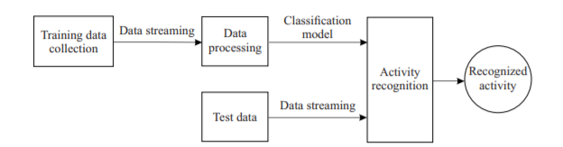

Figure 1

It is a core block behind these app. It takes the senor data reading as inputs and guesses a user’s motion action. Most of the main stream smartphones are furnished with many different sensors, including temperature sensors, accelerometers, barometer, GPS, gyroscope, light sensors, etc. These sensors record a data and it become a big data foundation to measure many characteristics of a humans daily life. The characteristic activities include jogging, sitting, walking, etc. because to its unobtrusiveness, none setting up price, and easy-use, smartphones are becoming one of the main stage for HAR . Figure 1 shows a characteristic process for activity recognition with sensors. Recognition of our activity is important in several real applications. Let us intricate this using the following ex. Begin with, as one division of human computer communication, makes the computer more “smarter”, that is, it could afford the equivalent facilities based on what the human is doing. For example, assume the user wants to leave the room or about the leave the room user smart phone detects and its weather app that it may rain later, a messages will shown in the home screen. ”Bring an umbrella. It is may rain with a high possibility”. One of the important app of activity recognition methods is in both inside and outside localizations for house navigation or enhancing the accuracy of context-aware service. Finally, the smartphones become as crucial as keys and the holder for a user’s pocket stuff these days, the activity recognition methods will help in supporting life in healthcare service. It could also help in the prevention of hazardous actions, such as aged people’s fall detection, youth Autism Spectrum Disorder (ASD) detection in a classroom, etc. It could also help in a proactive way. For ex, in order to ensure the user form a healthy fitness habit, the smartphone can send a reminder if it user has been laying too long. Many current popular fitness trackers are built upon sensors and activity recognition methods. They track people’s steps taken, distance travelled, , calorie burned, quality of sleep, stairs climbed, hours slept, etc.

Related work

In this research paper we mainly focus on the recognition of human activity using sensors by using accelerometer and gyroscope sensor smartphones. In this sensor detects human activity. We have 3 axial data for each sensor, x, y, z axis data for accelerometer and another 3 axial signal data for gyroscope and as expert made feature, we have total acceleration for x, y and z axis. We do a data cleaning first. Then we move on to Exploratory Data Analysis, we make charts of different kind in order to see whether we have enough data or not for each person for each class like walking, siting etc. we compare their accuracy and declare a couple of Machine Learning algorithms to e preferred over the others for this particular project. That was about the Machine Learning approach now we will talk about the Deep Learning approach.

1.A. Bayat, M. Pomplun and D. Tran, "A Study on Human Activity Recognition Using Accelerometer Data from Smartphones", Procedia Computer Science, vol. 34, pp. 450-457, 2014.

Ref Google Scholar

Bayat et al. studied on human activity recognition with accelerator signals offer a recognition system in which a new numerical low-pass filter is calculated in order to remove the module of gravity acceleration from that of body acceleration in the raw data.

2.F. Attal et al., "Physical Human Activity Recognition using Wearable Sensors", Sensors, vol. 15, no. 12, pp. 31314-31338, 2015.

Attal et al. tried to classify activity depending on wearable multiple gyroscope and accelerometers two forms namely, histogram of gradient and centroid signature based Fourier form, are working to cutting feature sets from these signals.

3.C. Ronao and S. Cho, "Human activity recognition with smartphone sensors using deep learning neural networks" in Expert Systems With Applications, Elsevier, vol. 59, pp. 235-244, 2016.

Ronao et al. structured a convolutional artificial neural network in demand to recognize user activity using smartphones accelerometer and gyroscope.

One more study that has used deep learning neural networks reached %94.79 success rate.

4.S. Kozina, H. Gjoreski, M. Gams and M. Lustrek, "Efficient activity recognition and fall detection using accelerometers" in Evaluating AAL Systems Through Competitive Benchmarking, Springer, pp. 13-23, 2013.

Google Scholar

Kozina et al. worked on fall detection using accelerometer

AAL systems should know the user’s state of affairs, which makes activity recognition an significant component. Falls are one of more critical problems of the aged people, so AAL classifications often include fall detection.

5.D. Anguita, A. Ghio, L. Oneto, X. Parra and I. L. Reyes-Ortiz, "A Public Domain Dataset for Human Activity Recognition Using Smartphones" in ESANN 2013 proceedings on European Symposium on Artificial Neural Networks Computational Intelligence and Machine Learning, Bruges:i6doc.com publ., 2013.

The noise was filtered using median and 20Hz Butterworth[5] filters in order to get more precise results.

Euclid magnitudes of the values of 3 dimensions calculated to merge 3 dimensional signal into one dataset[5].

6.HMC Web Site, [online] Available: http://fourier.eng.hmc.edu/e84/lectures/ActiveFilters/node6.html.

High and low pass butterworth filters[6].

7.M. Mohammed, M. B. Khan and E. B. M. Bashier, Machine Learning Algorithms and Applications., Florida:CRC Press, 2017.

It classifies data by flowing through a query structure from the root until it reaches the leaf, which represents one class[7].

8.F. Giseke, "From Supervised to Unsupervised Support Vector Machines and Applications in Astronomy", The Carl von Ossietzky University of Oldenburg Germany, 2011.

Although SVN can be used both with and without supervising, using supervised SVN is usually faster and more succesful[8].

9.Y. Freund and R. E. Schapire, "A Decision-Theoretic Generalization of On-Line Learning and an Application to Boosting" in Journal Of Computer and System Sciences, Elsevier, vol. 97, no. 55, pp. 119-139, 1997.

AdaBoost uses a sequential set of classifiers and aims to create a strong classifier out of weaker ones[9].

10.C. A. Shipp and L. I. Kuncheva, An Investigation into How ADABOOST Affects Classifier Diversity, [online] Available: http://pages.bangor.ac.uk/~masOOa/papers/cslkIPMU02.pdf.

Finally it normalizes all weights that the sum would be equal to 1[10].

11.T. G. Dietterich, "Ensemble Methods in Machine Learning", Lecture Notes In Computer Science - Multiple Classifier Systems, vol. 1857, pp. 1-15, 2000.

This method requires training data to be divided into subgroups and distributed to classifiers of the ensemble structure[11]. Group methods are meta-algorithms that associate several machine learning method into one predictive model in order to decrease bagging, bias boosting, or stacking.

12.L. Breiman, "Bagging Predictors" in Machine Learning, Springer, vol. 24, no. 2, pp. 123-140, 1996.

Aggregation is usually used to get more decisive results from sensitive learning algorithms like decision trees[12]. Bagging predicters is a method for producing many forms of an indicator and using these to get an collected indicator. The total midpoints over the adaptations while predicting a mathematical result and does a popular vote while do in advance a class. The different adaptations are framed by making bootstrap repeats of the learning set and using these as new learning sets.

Methodology

The Projected and Proposed Model is creating a computer aided automated system which recognizes the human activity using sensor data. At first, we load the data and check for any NaN, missing values, repeated columns etc. We do a data cleaning first. Then we move on to Exploratory Data Analysis, we make charts of different kind in order to see whether we have enough data or not for each person for each class like walking, siting etc. we also check whether we have enough data for each class from all people combined. We check through TSNe whether any two classes are overlapping, in that case they will be harder to classify. At last we employ six machine learning algorithms to do the classification, each applied with gridsearchcv and then we compare their accuracy and declare a couple of Machine Learning algorithms to e preferred over the others for this particular project. That was about the Machine Learning approach now we will talk about the Deep Learning approach. As we saw earlier, the machine learning approach employed expert created features in order to do its classification task, which is unnecessary in deep learning, however deep learning demands lots of data which in this case we don’t have, approaches like LSTM of Deep Learning can easily overfit on our small data of 7000 points, so we have kept the LSTM model small and simple. The LSTM model would take the 9 axial signals as input and will output 6 class classification result through its last dense layer. However, the signals are going to be processed though Fourier analysis by filtering to be done by signal processing experts before we can input it to the LSTM model. Explaining the ipython notebook As discussed, before we check for NaN, missing values, duplicate columns and here we had found some duplicate columns so we removed them for machine learning algorithms.

The dataset comes from UCI Machine Learning repository the link is here https://archive.ics.uci.edu/ml/datasets/human+activity+recognition+using+smartphones

We have a dataset consisting of readings from accelerometer and gyroscope sensor smartphones, the raw data is in time series format. We have 3 axial data for each sensor, x, y, z axis data for accelerometer and another 3 axial signal data for gyroscope and as expert made feature, we have total acceleration for x, y and z axis. This makes total timeseries data amount to 9. This might be enough for deep learning but for machine learning we also have 561 featured datasets, where the features were created by the experts in order to do better classification.

**The chart below shows how many data points we have for each person for each activity label:**

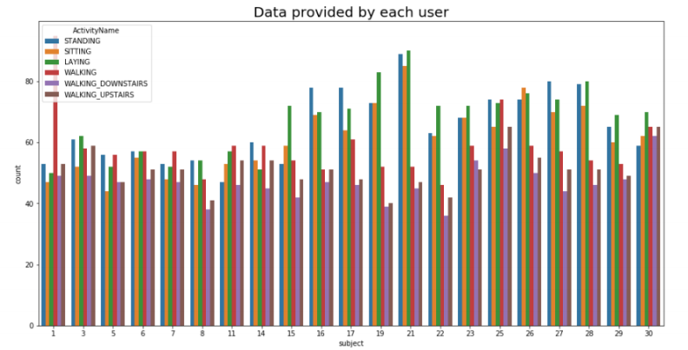

WHY WE USED GRID SEARCH ?

Grid search is a technique to make hyper-parameter optimisation, that is, it is a technique to find the best grouping of hyper-parameters (an example of an hyper-parameter is the learning rate of the optimiser), for a given model (e.g. a CNN) and test data from dataset. In this state, you have several models, each with a different combination of hyper-parameters. Each of these combinations of parameters, which correspond to a single model, can be said to lie on a point of a "grid". The goal is then to train each of these models and evaluate them e.g. using cross-validation. You then select the one that performed best.

Confusion matrix

Confusion matrix also know as"error matrix"

The earliest reference to the concept had been made by British Statisticia Karl Pearsonin 1904, A confusion matrix is a simple way to lay out how many predicted categories or classes were correctly predicted and how many were not. It is used to evaluate the results of a predictive model with a class outcome to see the number of classes that were correctly predicted as

their true class.

Confusion matrix is a table is often used to describe the performance of a classifier on a test data for which the true values are known.

* True positive (TP): positive and it's true

* True Negative (TN): Negative and it's true

• False positive (FP): Positive and it's false

• False Negative (FN): Negative and it's false

• Recall = TP/TP+FN

• Precision= TP/TP+FN

• Accuracy= TP+TN/P+N

• F1-score = 2*Recall*Precision/Recall+Precision

#How to Calculate a confusion matrix.

1. First, you need to test data set with it's expected out come values

2. Predict all the rows in the test data set.

3. Calculate the expected predicted and out comes.

TRYING MACHINE LEARNING ALGORITHMS GRID SEARCH :

Logistic regression with grid search:

In logistic regression we got accuracy =0.9626739 . It is one of the frequently used Machine Learning technique that is used to model a binary variable that takes only 2 values – 0 and 1.

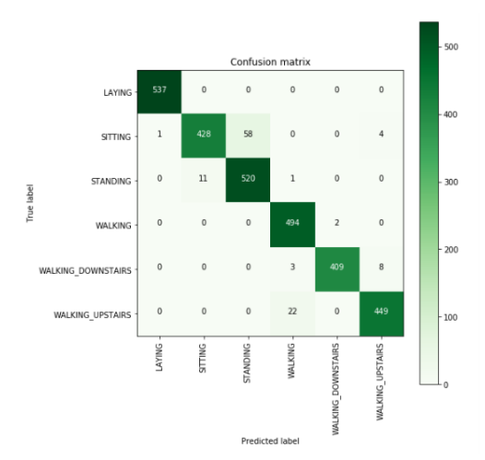

Linear SVC with grid search:

In linear SVC we got accuracy = 0.96640 . The impartial of a Linear SVC (Support Vector Classifier) is to fit to the data you afford, returning a "best fit" hyperplane that divisions, or catalogues, your data. From there, after getting the hyperplane, you can then feed some structures to your classifier to see what the "foreseen" class is. This makes this exact algorithm rather fit for our uses, however you can use this for most of the situations.

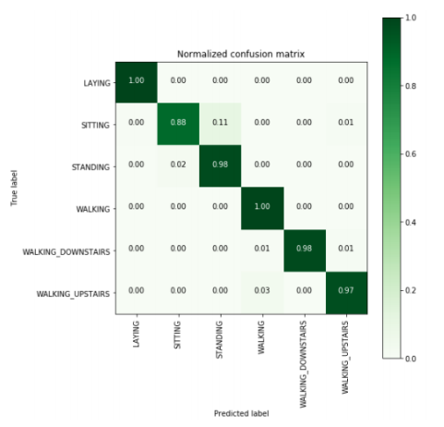

Kernel SVM with grid search:

In linear SVM we got accuracy = 0.963691. It deals with higher and non-linearity dimensions. It is also used for regression the algorithm tries to find out the optimal hyper plane which can be used to classify new data points. In 2 dimensional hyperplane is a simple line . other algorithms learn about difference while this algorithm learn about similarities.

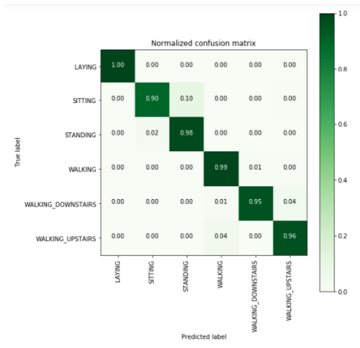

Decision tree with grid search:

In Decision tree we got accuracy = 0.863590 .Decision trees effectively communicates complex processes Decision trees focuses on probability of data, not emotion and bias.

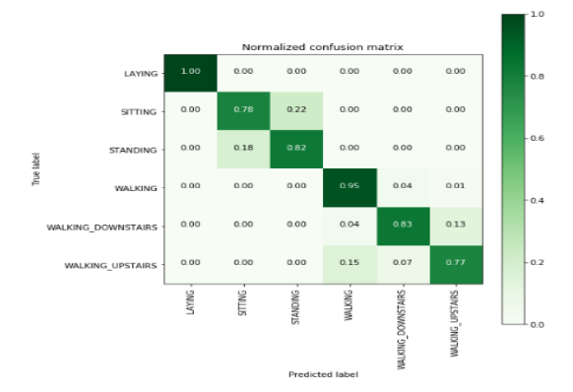

Random Forest classifier with grid search:

In random forest classifier we got accuracy = 0.907702 Random Forest is an group learning tech that is flexible and easy to use. It is one of the frequently used algorithms, because of its simplicity and it can be used for both classification and regression tasks. It is a meta estimator that fits a number of decision tree classifiers on various sub-samples of the dataset. It combats high variance by adding added randomness to the model, while growing the trees.

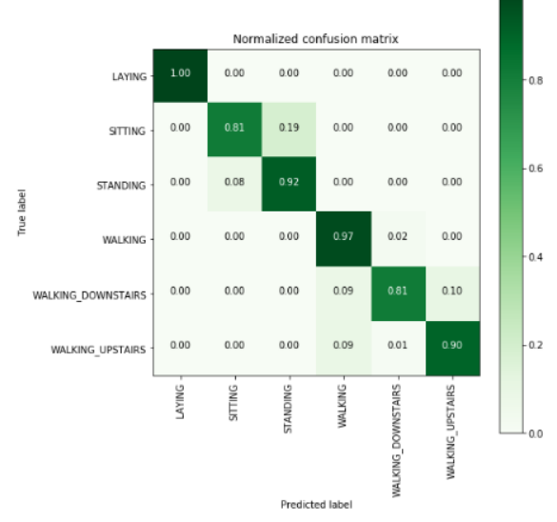

Gradient boosted decision trees with grid search

Gradient boosted decision trees with grid search we got accuracy =0. is a group of machine learning algorithms that combined most of the weak learning models together to create a strong predictive model. Decision trees are usually used when doing gradient boosting. Gradient boosting models are becoming general because of their usefulness at categorizing complex datasets, 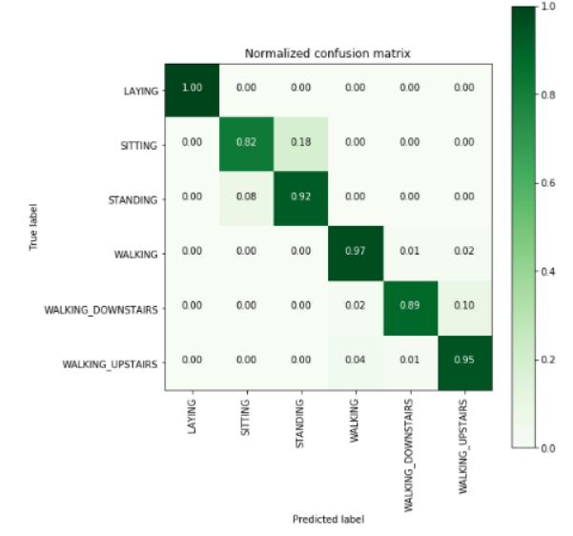

Results

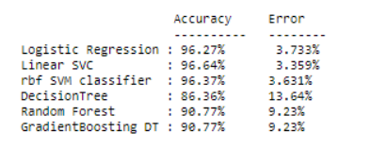

**The Deep Learning approach using LSTM: ▪**

We define some functions to print confusion matrix, to read a csv using pandas of course, and to load the dataset as the dataset is in form of text files and we must combine readings of every instant from all of 9 axial signals.

We import tensorflow, open a new session, import modules for LSTM and set our epochs, batch size, and number of hiddent layers. Then we load the data using the defined function

For LSTM I am using tensorflow module Distributed compute support. The graphs can span several computers. Tensorflow has comparatively good documentation Backing from a large company like Google Support for GPUs. Now it is coming up with XLA, which has presentation improvements.

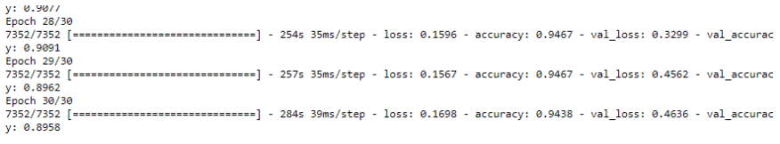

Discussion & Conclusion

The main reason behind the project is to create an automated computer aided system which helps to detect the human activity and classify the state of the human body like sitting, standing, walking, laying, walking upstairs , walking downstairs Human activity recognition is a core building block behind these applications. It takes the smartphone sensors data analysis as inputs and predicts a human activity. This paper grants a full survey of the recent developments in activity recognition with sensors. We present the elementary concepts of activity recognition such as sensors, activity types, etc. We review the core data method behind the main stream activity recognition algorithms, analyze their main tests, and present a variability of real applications allowed by activity recognition. The activity recognition leads to many possible future research directions. Besides the applications an even novel way could be preparing smartphones with intelligent applications to replace the traditional devices such as remote control, traffic controlling. Smartphone apps that can detects users’ gestures could send corresponding command to home electronics

Final result

LSTM gives 89% per accuracy while Machine Learning models gave 96%. But the point to remember is the cost of hiring the experts to create the features needed for ML algos while deep learning needs none of that.

Reference :

1.A. Bayat, M. Pomplun and D. Tran, "A Study on Human Activity Recognition Using Accelerometer Data from Smartphones", Procedia Computer Science, vol. 34, pp. 450-457, 2014.

2.F. Attal et al., "Physical Human Activity Recognition using Wearable Sensors", Sensors, vol. 15, no. 12, pp. 31314-31338, 2015.

3.C. Ronao and S. Cho, "Human activity recognition with smartphone sensors using deep learning neural networks" in Expert Systems With Applications, Elsevier, vol. 59, pp. 235-244, 2016

4.S. Kozina, H. Gjoreski, M. Gams and M. Lustrek, "Efficient activity recognition and fall detection using accelerometers" in Evaluating AAL Systems Through Competitive Benchmarking, Springer, pp. 13-23, 2013.

5.D. Anguita, A. Ghio, L. Oneto, X. Parra and I. L. Reyes-Ortiz, "A Public Domain Dataset for Human Activity Recognition Using Smartphones" in ESANN 2013 proceedings on European Symposium on Artificial Neural Networks Computational Intelligence and Machine Learning, Bruges:i6doc.com publ., 2013.

6.HMC Web Site, [online] Available: http://fourier.eng.hmc.edu/e84/lectures/ActiveFilters/node6.html.

7.M. Mohammed, M. B. Khan and E. B. M. Bashier, Machine Learning Algorithms and Applications., Florida:CRC Press, 2017.

8.F. Giseke, "From Supervised to Unsupervised Support Vector Machines and Applications in Astronomy", The Carl von Ossietzky University of Oldenburg Germany, 2011.

9.Y. Freund and R. E. Schapire, "A Decision-Theoretic Generalization of On-Line Learning and an Application to Boosting" in Journal Of Computer and System Sciences, Elsevier, vol. 97, no. 55, pp. 119-139, 1997.

10.C. A. Shipp and L. I. Kuncheva, An Investigation into How ADABOOST Affects Classifier Diversity, [online] Available: http://pages.bangor.ac.uk/~masOOa/papers/cslkIPMU02.pdf

11.T. G. Dietterich, "Ensemble Methods in Machine Learning", Lecture Notes In Computer Science - Multiple Classifier Systems, vol. 1857, pp. 1-15, 2000.

12.L. Breiman, "Bagging Predictors" in Machine Learning, Springer, vol. 24, no. 2, pp. 123-140, 1996.

GITHUB LINK